IPSC Master Seedstock Winners
(Videos of the winners have been produced since 2018; click on the links to view them.)

2023
Barnes, Ernie - Adel

2022
Sieren, Jayme and Sieren, Scott - Keota

2021
Triggs, Kevin - Mount Ayr

2020
Fee, Rod - Ackworth

2019
Owen, Bill and Bob - Riceville
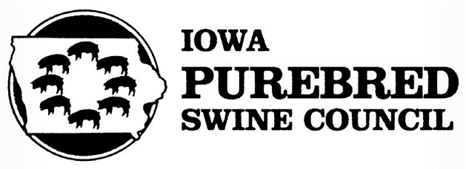
2018
Abbas, Rick and Ryan - Aplington

2017
Schminke, Al - Van Horne

2016
Engler, Dan - Nevada (awarded posthumously)

2015
Huinker, Wayne & Roxanne - Decorah

2014
Iverson, Ron - Grinnell

2013
Rohrig, Matt - Orient

2012
Albertsen, Franklin - Toledo

2011
Behnkendorf, Bob - Algona

2010
Tucker, Bill & Melissa - New London

2009
England, Doug & Priscilla - Clearfield

2008
Conover, Brice - Baxter

2007
Burzlaff, Dan - Delmar

2006
Christian, Kay - Woodward

2005
Warrick, John - Prairie City
Warrick, Ron - Gowrie

2004
Eddie, Brad and Mike - Storm Lake

2003
Conover, Adam and Zeisneiss, Robert - Baxter

2002
Steffensmeier, LeRoy & family - Fort Madison

2001
Albertson, Neil & Lisa - Fremont
Martin, David - Marion

2000
Kerns, Steve & Becky - Clearfield
Stewart, Doug - Waverly

1999
Brown, Ray & Linda, Luke - West Bend
Cain, Earl & Patty, Lee - Chariton
ISU Swine Teaching Farm - Ames

1998
Hodson, Harold & Rouse, Gene - Huxley
Schmidt, Randy & Becky - Williamsburg

1997
Grimm, Jim - Maynard

1996
Olson, Brad - Atkins

1995
Compart, Marc - Lehigh

1994
Neher, Lyle & Paul - Grundy Center

1993
Huinker, Dennis - Calmar
Huinker, John - Decorah

1992
Edwards, Lawrence - Lawton

1991
Schram, Lyle & Jeremy - Anthon
1990
Martin, A. W. - Fayette

1989
Davis, Ken & Brad - Mediapolis

1988
Olsen, G. Wayne - Atlantic

1987
Lister, Terry - Bloomfield

1986
Meinhart, Myron - Hudson

1985
Brink, Jerry - Elkader
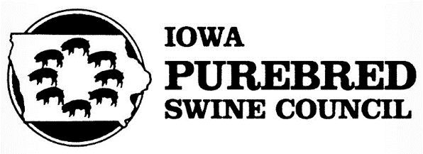
1984
Biensen, George & Kelly - State Center
Petersen, Merle L. - Guthrie Center

1983
Schminke, Walter - Van Horne
Swartzlander, Elmer - Indianola
Swartzlander, Robert - Corydon

1982
Martin, Doug - Fayette
Mensing, Verlynn - Iowa Falls

1981
Christian, Kay - Woodward
Walker, Bob - Mystic

1980
Harper, Joe - Colo
Hoffman, Dr. Peter - Ames
Olson Spot Farm, Craig & Mark - Newhall

1979
Martin, Loyd - Marion

1978
Heaberlin, Steve - Pleasantville

1977
Christian & Granzow - Roland
Meeker, Orville - Letts
Pothast, Norman - Spencer

1976
Martin, Stan - Postville
Stewart, Dave - Waverly
Willson, Gerald - Cresco

1975
Irons, Jim - Clarence
Klein, Willard - Iowa Falls
Wiese, Vern - De Witt

1974
Conover, Tom - Holstein
McCarthy, Edward - Oelwein
Schram, Lyle - Anthon

1973
Brown, J. Verald - Hampton
Dimig, Joe - Atlantic
Moran, John J. - Woodward

1972
Huisman, Gary - Clarksville
Norris, Lee - Fremont
Pangburn, Milo & Son - Northwood

1971
Anderson Spot Farm - Kellogg
Huinker, Dennis - Decorah
Williamson, Clarence - Eagle Grove

1970
Dee Brothers - State Center
Kehrli, Wilbur - Manchester
Rath Packing Company - Waterloo

1969
Beri, Richard - Letts
Klingaman, Dick - Waterloo
Tucker, Darrell - New London

1968
Curtiss, Harold & Charles - Churdan
Kuecker, Dick - Algona
Wendt, Kenneth - Buckingham

1967
Berry, Howard - Iowa City
Broek, John - Sioux Center
McGraw, Dale - Pleasantville

1966
Dowden & Son - Conrad
Olson, Lyle & Owen - Atkins
Soorholtz, John - Melbourne

1965
Eddie Brothers - Storm Lake
Mordhorst, Elmer - Soldier
Westre, Dale - Lehigh

1964
Dielschneider, Willard - Conrad
Ekstrom, Ray - Vincent
Smith, C. W. - Mount Vernon

1963
Cooper, C. J. & Sons - Hartley
Hirsch, Carl & Son - Indianola
Jackson, F. J. & Son - Lytton

1962
Christian, F. H. & Sons - La Porte City
Lang, Allen & Son - Brooklyn
Merryman, Willard - Marshalltown
1961
Farmers Hybrid - Hampton
Helgens, Ed - Monticello
Hemm, Bill - Sheffield

1960
Goodchild, Fred & Sons - Mallard
Keen, Berl - Le Grand
Knickerbocker, Gesley - Radcliffe

1959
Friedow, Floyd & Sons - Kanawha
Mears, Harold - Jefferson
Thomas, Ted - Iowa City

1958
Lange, Wallace & Son - Brooklyn
Meinhart, Wilbert - Hudson
Weed, Bernard & Sons - Ute

